Design, development and deployment of accelerator magnets in RRCAT and future challenges
Shesh Nath Singh
Accelerator Magnet Technology Division,
Raja Ramanna Centre for Advanced Technology, Indore, India
Abstract
RRCAT houses Indus-1 and Indus-2 which are two synchrotron radiation sources designed and developed in early 1990s. Indus-1 is a 450 MeV, 125 mA machine and has been operational since 1999. Indus-2 is a 2.5 GeV, 200 mA machine and has been operational since 2005. RRCAT has also developed an Infrared Free Electron Laser (IRFEL) and a few low energy linear accelerators for electron beam processing of agricultural and medical products.

More than 300 normal conducting magnets have been used in the above accelerators. These magnets were designed in RRCAT, developed with the support of indigenous industry and characterized in RRCAT. These magnets include dipoles, quadrupoles, sextupoles, solenoids, pulsed magnets and special purpose magnets. Now, it is planned to build a high brilliance synchrotron radiation source, for which we will have to design and develop various magnets and insertion devices. We are in the process of preparing ourselves for this challenge which, we are aware, will have requirements much more difficult to meet. In this talk, a short overview of the design and development of various magnets so far will be presented along with the challenges we foresee to face and how we are planning to overcome them.

=======

Topics

An Example of TPS
MAGNET DESIGN AND CONTROL OF FIELD QUALITY FOR TPS BOOSTER AND STORAGE RING
https://accelconf.web.cern.ch/ipac2015/talks/tuad1_talk.pdf
Outline
Introduction
Magnet manufacture and inspection
Mechanical error of magnet
Magnetic field performance of magnet
Magnet center inspection
Permeability inspect of BR vacuum chamber
Field distortion from the permeability chamber
Summary

Milestone of magnet manufacturer
2005 Preliminary design of the magnet
2007 TPS project approved
2009 Magnet prototype constructed and examined in house
2011 One-section prototype (23 magnets) finished
2012 Mass production of magnet was begun
2013 Oct. All magnets completed
2014 Aug. Accelerator install completed
2014 mid-Dec. Hardware testing and improvement completed
2014 Dec. 31 First synchrotron light at 3 GeV was observed
(no corrector applied)

Outline (Magnet Mass Production and Field Measurements Results for TPS)
Field measurement system
- Hall Probe, Rotating coil, search coil
Magnet alignment method
Inspection of Storage ring magnets
Inspection of Booster ring magnets
Injection Magnets
Summary

—----------
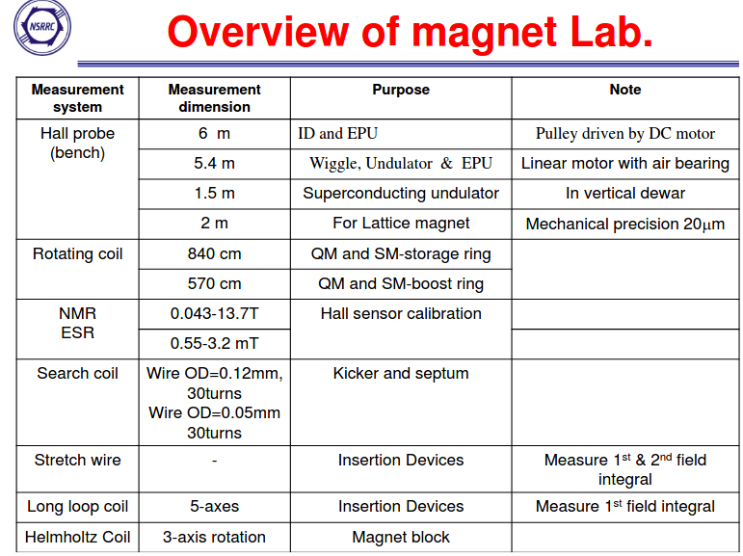

—-------------
Summary
- The machining error of the pole profile of a TPS magnet is better than 0.02 mm as manufactured with the CNC and WEDM techniques. The multipole errors of these magnets thereby conform to the strict requirements of the spec.
- A precise mechanical and magnetic center was shimmed and measured with the CMM and RCS. The mechanical center offset was shimmed better than 0.01 mm in both vertical and horizontal directions.
- The magnetic center offset was better than 0.02 mm in both vertical and horizontal directions after feet-shim.
- The mechanical and magnetic tilt of magnet is better than 0.01º after feet-shim.
- The permeability of the BR chamber was less than 1.01 after heat treatment.
- A serious distortion of the field from the un-annealed chamber was observed, indicates that the electron beam at low energy will be perturbed seriously due to the effect of un-annealed chamber in the BR.

=======================

??? Do we have photo of first synchrotron light from Indus-2 ?

Can we do top-up injection ?
In order to verify the magnetic field quality and the leakage field distribution, the search coil probe and the printed circuit technology for long coil probe measurement systems are developed and implemented for magnetic field measurement.

=========

References

MEASUREMENT OF INJECTION SYSTEM OF AC SEPTUM MAGNETS FOR TPS STORAGE RING (IPAC2012)
https://accelconf.web.cern.ch/ipac2012/papers/thppd012.pdf

Magnet Mass Production and Field Measurements Results for TPS (2013)
https://indico.bnl.gov/event/609/contributions/15425/attachments/13750/16827/IMMW18-CSHwang1.pdf

