HIP Processing of Improved Tooling Materials for High-Productivity Hot Metal Forming Processes
Maxime Gauthier^{1,a *}, Guillaume D’Amours^{2,b} and Fabrice Bernier^{1,c}
¹ Automotive and Surface Transportation Research Centre
National Research Council Canada
75, de Mortagne Blvd., Boucherville (Québec), Canada, J4B 6Y4
² Aluminum Technology Center
National Research Council Canada
501, Université-Est Blvd., Saguenay (Québec), Canada, G7H 8C3
ª Maxime.Gauthier@cnrc-nrc.gc.ca, ^{b} Guillaume.Damours@cnrc-nrc.gc.ca,
^{c} Fabrice.Bernier@cnrc-nrc.gc.ca
Keywords: Hot Isostatic Pressing, HIP, tool steels, metal matrix composites, hot working, hot stamping, hot metal forming, automotive, tooling, thermal conductivity
Abstract. Much work has been carried out in the last decade on the development of high performance alloys to reduce vehicle weight. These alloys are often characterized by low room-temperature formability. A variety of hot forming processes (hot stamping, hot extrusion and high-pressure die casting) are thus being used or adapted for these alloys. The final mechanical properties, shape complexity and production cost of parts made using these processes will be closely related to mold/die thermal and mechanical performance.

Hot work tool steels generally have the required mechanical properties and durability to meet hot-processing requirements but have low thermal conductivity. The stringent low processing cost and high-volume production requirements of the automotive industry compel part producers to find ways to shorten unit production times at equivalent product quality. In order to meet the processing requirements of advanced alloys and transfer heat more rapidly, the tooling should thus have a higher thermal conductivity than the standard tool steel dies currently in use.

The aim of this work is to optimize die properties to improve heat transfer kinetics during part shaping, thus providing an increase in efficiency and productivity for automotive metal part manufacturing. Hot Isostatic Pressing (HIP) has been used to clad a conformal-cooled copper core with a layer of either hot-work tool steel or High-Thermal Conductivity (HTC) composite material designed at NRC. Properties and performance of these systems are compared with those of standard tool materials to demonstrate the practical potential for future development and optimization of advanced tooling.

Introduction. A promising way to manufacture structural automotive components using high strength AA7xxx aluminum alloy sheets is through the hot stamping process. The process itself is not new and is currently used in production with boron steel sheets. Rana et al. [1] provides different process details with boron steel and the average processing time is about 7 min for each part. For AA7xxx aluminum alloy sheets, the hot stamping processing sequence can be summarized as follows: 1) a blank sheet is heat treated to put the alloying elements into solid solution, 2) the blank is rapidly transferred to the press, 3) the die is partially closed to shape the part and 4) the die is completely closed to quench the shaped part and prepare the alloy for precipitation 5) the part is removed from the press and artificially aged to reach high mechanical strength. The hot stamping process with aluminum is similar to steel except that the solution heat treatment step is longer and aluminum's thermal conductivity is higher. During the last few years, aluminum alloys for hot stamping have attracted the interest of many scientists. Quenching rate effects for AA7xxx alloys have been analyzed by Keci et al. [2] and Kumar et al. [3]. High temperature mechanical behavior and high temperature formability analysis and modeling have been analyzed by Mohamed [4] and Elfakir [5]. Harrison et al. [6] have also produced real AA7xxx aluminum alloy pillars using hot stamping.
Due to the major investments required for future part production, another vital process parameter to consider is the hot stamping cycle time. During blank quenching, heat is transferred to the die, the latter being cooled either by flowing water or oil via internal cooling channels. Conventional tool steels are used for the dies, yet their thermal conductivity is low, which increases the cycle time. The development of HTC tool steels would thus contribute to the improvement of hot working efficiency and productivity, which would be beneficial for the automotive industry where large production volumes require low processing times and costs.

Experimental. HIP processing and characterization of reference tool steel and HTC composite : Spherical powders of D2 tool steel powder (-150+45 μm, Sandvik) and of pure copper (grade 153A, 2%max+100μm / bal+45μm / 10%max-45μm, ACuPowder) were used to process the materials required for this study. D2 is not generally used for hot working, but it was chosen as it has been a reference for different sheet forming studies at NRC during the last few years, so comparisons with earlier work could easily be made (smaller-scale preliminary work based on H13 tool steel gave similar results [7]). For the production of the D2 reference and the development of the HTC tool steel, cylindrical 304L stainless steel canisters (190 mm-high, 138mm OD, 1.59 mm wall thickness) were filled with either D2 powder or a D2+30vol.% Cu blend and tapped to tap density. A cover plate featuring a tube for gas evacuation was welded on top of each of the canisters, which were then submitted to a vacuum degassing treatment (14h @ 150°C, 4h @ 550°C under mechanical vacuum (∼7x10⁻² Torr)). After mechanical crimping of the vacuum tubes and sealing by TIG welding, each canister was then HIPed in a model AIP10-30H hot isostatic press from American Isostatic Presses, Inc. The HIP parameters chosen for the pure D2 material were the following: 4h @ 1100°C and 15000 PSI (103 MPa). In the case of the D2+30vol.% Cu blend, the HIP plateau temperature was decreased to 1000°C to avoid formation of a liquid Cu phase. No additional heat treatment was applied to the resulting HIPed materials.

After HIPing, coupons were machined out of the D2 and D2+30vol.% Cu billets by wire Electro-Discharge Machining (w-EDM). These specimens were used for evaluation of Heat Capacity (C_{p}) by Differential Scanning Calorimetry (NETZSCH DSC 404F3), Thermal Diffusivity (α) by Laser Flash Analysis (NETZSCH LFA 457 Microflash) and Hardness (Instron Series B2000). Thermal Conductivity (k) was calculated using the measured C_{p} and α values by means of the following relationship, where ρ is the density of the material:

$α=\frac{k}{ρC_{p}}$ (1)

HIP processing of hot stamping dies: The processing of conformal-cooled, hemispherical toolings followed similar processing steps and HIP parameters as were used for the tool steel and HTC composite processing. Three dies were processed: 1) D2 reference, 2) 2mm-thick D2 layer HIP-clad on a solid Cu core and 3) 2mm-thick D2+30vol.% Cu layer HIP-clad on a solid Cu core - see Fig. 1a) to c). HIP temperatures were 1100°C for the D2 reference and 1000°C for the Cu-containing dies.
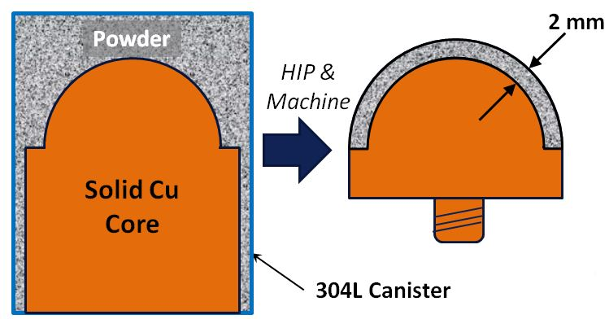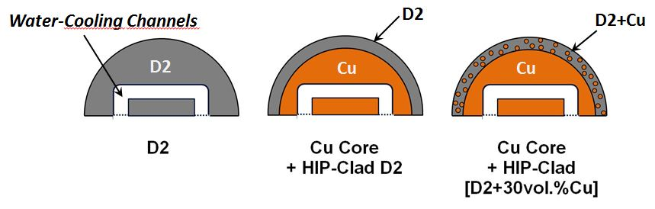
a) b)

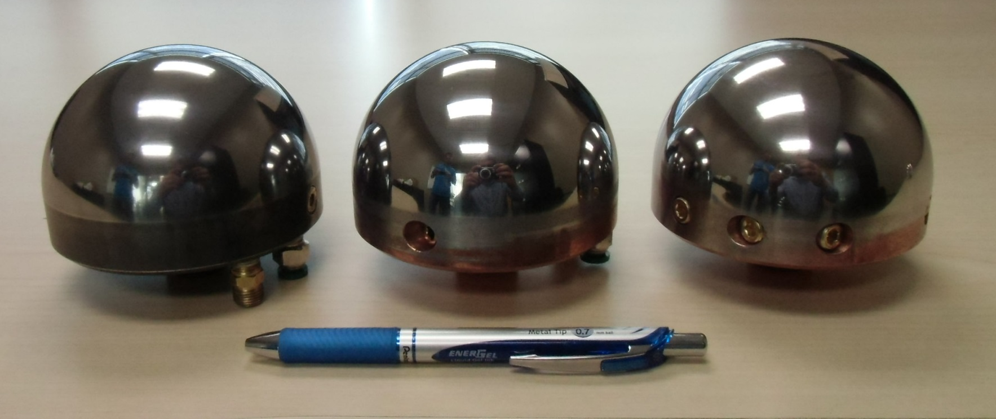
Cu Core
+ HIP-Clad D2
Cu Core
+ HIP-Clad [D2+30vol.%Cu]
D2

c)

Figure 1: | Conformal-Cooled, Hemispherical dies:  - Schematic cross-section of canister with core and powder used to prepare HIP-clad toolings;  - Schematic cross-sections of the dome part of toolings processed by HIP;  - Hemispherical toolings processed by HIP

Laboratory-scale aluminum hot stamping process: Study of hot stamping of AA7xxx sheets using these dies was carried out using a laboratory scale, hot-stamping test setup designed and installed on a 100 kN MTS hydraulic system (Fig. 2). With this particular test equipment, it was possible to reproduce the same steps during the same period of time as in production, except that some manual operations had to be carried out. During each test, a hot blank (sheet) was placed in the binder that was then partially closed; the die then rapidly deformed the blank to a specific position. Heat was partially transferred to the binder but mainly to the die due to higher contact pressures. The tooling was water-cooled and three, Omega 20-mil exposed thermocouples with thermal conductive paste were introduced by the bottom side up to very near the upper die surface.

The D2 tool steel die was first used for ten identical hot stamping tests. The cycle time was constant and adjusted to let the die cool down to a steady-state temperature. Afterwards, the tooling with HIP-clad D2 over Cu was used and ten additional tests were repeated for the same cycle time. Finally, the die with HIP-clad D2+30%Cu over Cu was tested using the same procedure.

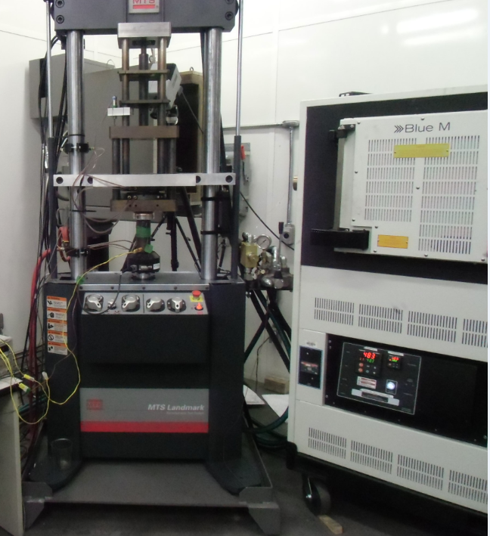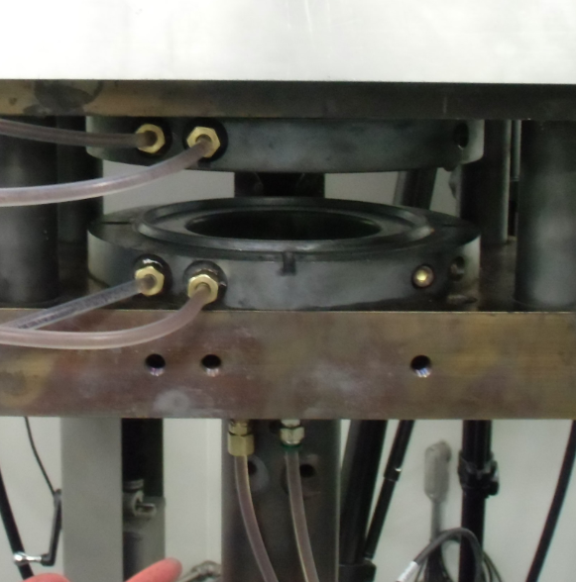

Figure 2: | Four-inch Nakazima set-up for hot stamping trials.

Results. Characterization of D2 tool steel reference and HTC composite: The calculated thermal conductivity values at relevant temperatures are shown in Figure 3a. It is seen that the thermal conductivity of the HTC composite is significantly higher than that of the D2 base steel at all temperatures (close to double the D2 reference value). This proves that the strategy of adding Cu to D2 to improve k gave good results. In the case of hardness (Fig.3b), as was to be expected, the hardness of the Cu-containing material is much lower than that of the pure D2 counterpart.

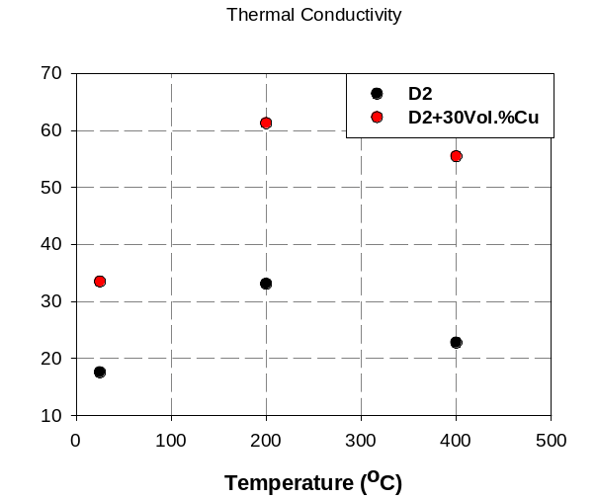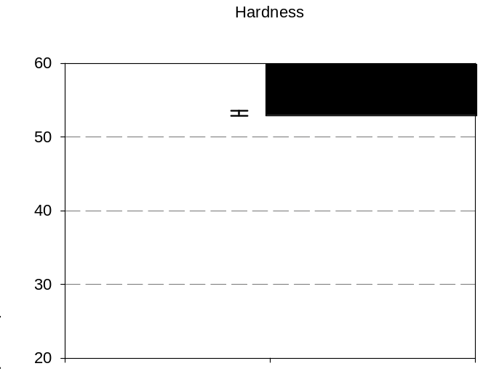
a) b)

Figure 3: | - Thermal conductivity of D2 and HTC composite at 25, 200 and 400°C;  - Room temperature hardness of D2 and HTC composite;
Nakazima hot stamping results: Hot stamping trials of AA7xxx sheets were repeated ten times with each tooling. The first tested die was the one made of D2 reference tool steel. Fig. 4 shows the die temperature for the last (tenth) stamping test. The acquisition time was six minutes per test and an interval of one minute between each test was maintained. The water temperature in the cooling lines was less than 283 K (10°C).
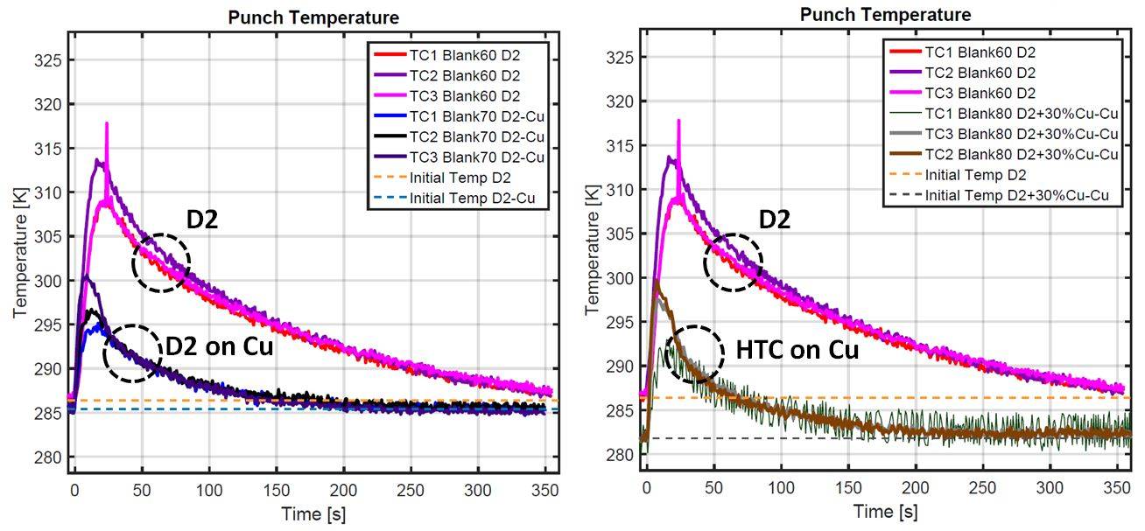
Figure 4: | Thermocouple temperatures for the three different dies

Fig. 4 shows that the D2 steel tooling temperature (upper three curves – both graphs are identical for D2 values) did not reach thermal equilibrium, even with more than six min of rest. The maximum temperature measured by the thermocouples for the D2 steel die for this particular test was 314 K (41°C), which occurred 16 sec after the die made contact with the blank. This shows the time required for heat to be transferred into the D2 tool steel, even if die thermocouples were close to the surface in contact with the aluminum alloy sheet. The last 300 sec of acquisition were used to extrapolate the D2 temperature curves up to a line corresponding to the initial die temperature, with the use of an exponential function. This procedure was also repeated for the four tests preceding the tenth one in order to generate average values for a total of five tests.

Table 2: Time required to reach die temperature equilibrium after hot stamping

Die material | Mean time to reach equilibrium (s) | Fraction of D2 reference mean time to reach equilibrium (%) | Gain in Efficiency (%)
D2 | 381 | - | -
D2 over Cu | 181 | 48 | 110
D2+30%Cu over Cu | 168 | 44 | 127

The slopes of the exponential extrapolations at the intersection with the line representing the initial die temperatures were also recorded and scaled by the differences between the maximum die temperatures, as recorded by the thermocouples, and the initial die temperatures. These slopes can be used to represent the heat transfer and the cooling rate at that particular moment of a given die temperature vs. time curve. When these slopes become small, this suggests that thermal equilibrium is close to being reached. For the two other die materials, the same procedure was applied to find the time needed to reach thermal equilibrium. The die temperature curves for these new materials are also shown in Fig. 4: "D2 on Cu" (left-hand graph) and "HTC on Cu" (right-hand graph). A significant difference in heat transfer behavior is observed for these two materials when compared to that of the D2 steel. Essentially, they are showing lower maximum values, showing the higher heat transfer rates of the "HIP-clad/copper core" toolings. The slopes of these curves were also analyzed, normalized and compared to the normalized slopes obtained for the D2 steel. The cooling time at which the normalized slopes were equal was used to determine the start of thermal equilibrium; these mean time values are presented in Table 2 for each die material. It can be seen that the HIP-clad D2+30%Cu on a copper core leads to the lowest cooling time (only 44% of the cooling time of the D2 reference die). The gain in efficiency values of the two improved dies are seen to be >100% and were computed using:

$Gain in Efficiency= \left\{\left[\frac{(Cycle time D2)}{(Cycle time improved die)}\right]-1\right\}×100$ (2)

Conclusion. A HTC composite, hot-work tooling material was successfully processed by HIP. Its thermal conductivity was improved over the D2 reference, while its hardness was lower.
Based on these available thermal and mechanical properties, development work on an optimal HTC composite should continue.

Conformal-cooled, hemispherical toolings were manufactured by HIP and used for hot stamping of AA7xxx sheets. Die cooling performance was as follows: HTC on Cu > D2 on Cu > D2. Gains in efficiency were of 127% for HIP-clad HTC on Cu and 110% for HIP-clad D2 on Cu. A thin, HIP-clad layer of HTC tool steel on a conformal-cooled copper core significantly contributes to productivity increase and should be considered for automotive sheet forming.

References
[1] R. Rana, S.B. Singh, Automotive Steels, Design, Metallurgy, Processing and Applications, Woodhead Publishing, first ed., (2017).
[2] A. Keci, N. Harrison, S. Luckey, Experimental Evaluation of the Quench Rate of AA7075, SAE Technical Paper 2014-01-0984, (2014).
[3] M. Kumar, N.G. Ross, Investigations on the Hot Stamping of AW-7921-T4 Alloy Sheet, Advances in Materials Science and Engineering (2017) 567-573.
[4] M.S.K. Mohamed, An Investigation of Hot Forming Quench Process for AA6082 Aluminium Alloys, PhD thesis, Imperial College London, 2010.
[5] O. Elfakir, Studies on the Solution Heat Treatment, Forming and In-Die Quenching Process in the Production of Lightweight Alloy Components, PhD thesis, Imperial College London, 2015.
[6] N. R. Harrison, S.G. Luckey, Hot Stamping of a B-Pillar Outer From High Strength Aluminum Sheet AA7075, Sae International Journal of Materials & Manufacturing 7(3) (2014) 567-573.
[7] F. Bernier, M. Gauthier, unpublished NRC work.

